Note: Private and protected cannot be used with class. The only modifier can be used with classes are ‘final, abstract and public’. So we can’t make classes as private or protected.

Following are the access modifiers

1. Default: Default means ONLY accessible within same package. It is also known as package private.
2. Public: To accessible anywhere
3. Protected: Accessible between parents and subclasses.

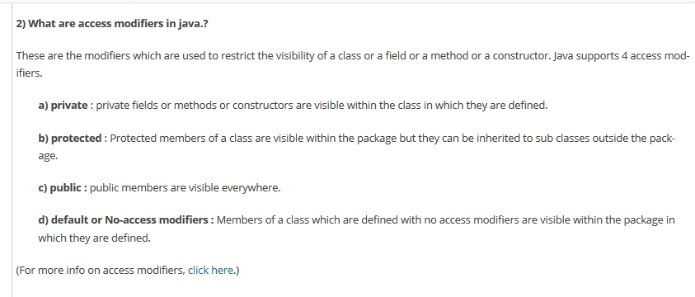

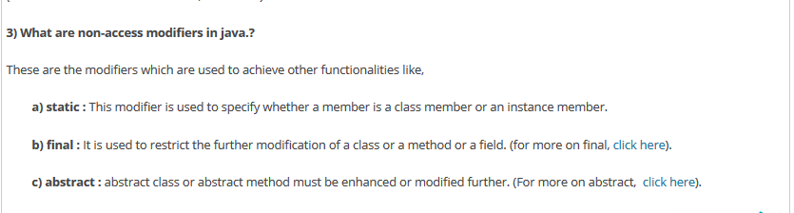



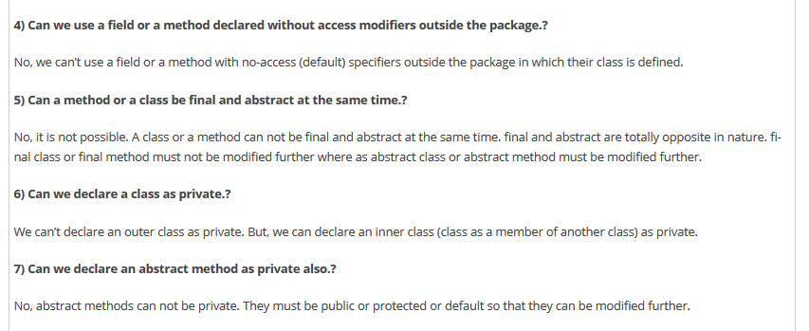

From another site:

**Access Modifiers In Java :**

Access modifiers in java are used to control the visibility of a field, method, class and constructor. There are 4 access modifiers in java. They are : **1). Private   2). Default or Package  3). Protected  4). Public**

## 1). Private

**Usage of Private members :**

Private members of a class whether it is a field or method or constructor can not be accessed outside the class.

**Inheritance of Private Members :**

Private members will not be inherited to sub class.

**Important Note :**

1). Class can not be a private except inner classes. Inner classes are nothing but again members of outer class. So members of a class (field, method, constructor and inner class) can be private but not the class itself.

2). We can’t create sub classes to that class which has only private constructors.

|  |  |
| --- | --- |
| private class A  {       //Outer class Can not be private  } | |
| 1  2  3  4  5  6  7  8  9  10  11  12  13  14  15  16  17 | class A  {      private A()      {          //Private Constructor      }      private A(int i)      {          //Private constructor      }  }    class B extends A  {      //Can't create subclass to the class      //which has only private constructors  } | |

